* **Item Ledger**

1. Click Menu
2. Click Reports
3. Click Item Ledger

Item Ledger

Reports

Menu

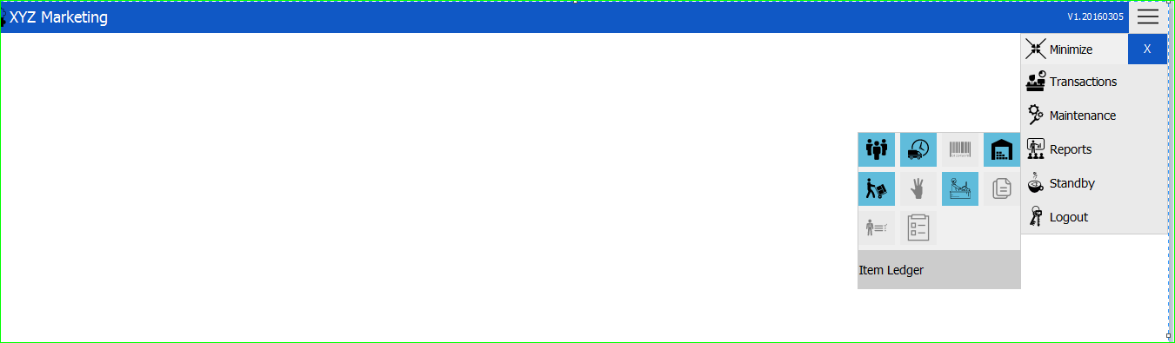

* **New Item Ledger Transaction**

Search Bar

Item Search Filters

Locations

Date Search Filters

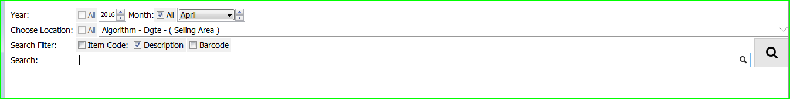

1. Date Search Filters



**Note: If you want to show the transaction every month, you can just uncheck the checkbox and then choose month.**

1. 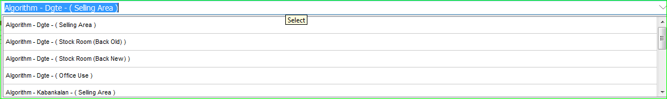Choose Locations

**Note: Algorithm - Dgte - ( Selling Area ) is the default location. You can just press enter to show all lists of the locations.**

1. Item Search Filters



**Note: You can search item by using:**

1. **Item name/code**
2. **Barcode (Input/Scan)**
3. **Item description**

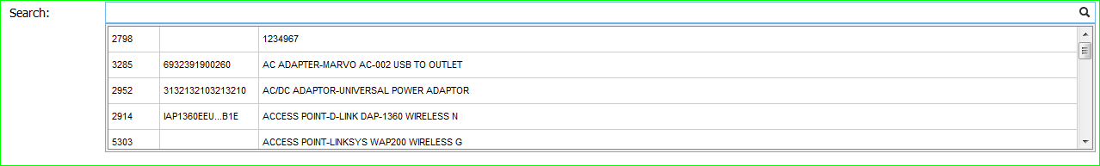 4. Search Bar

**Note: You can also press enter to view all item lists.**

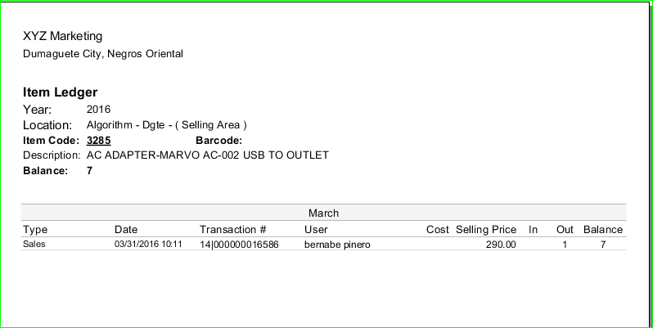**Item Ledger for the Month of March**

ItdfdsI **It shows all the transactions including the item balance.**